Internet of Things_project
Name: Khwaja nawaz
Task 1: Design a Data Injector Component using Urban Observatory Data.
Objective:
The main goal of this task is to create a data injector that collect real world data from the Urban Observatory and then sends it to an MQTT broker so the next task can use it.
Implementation:
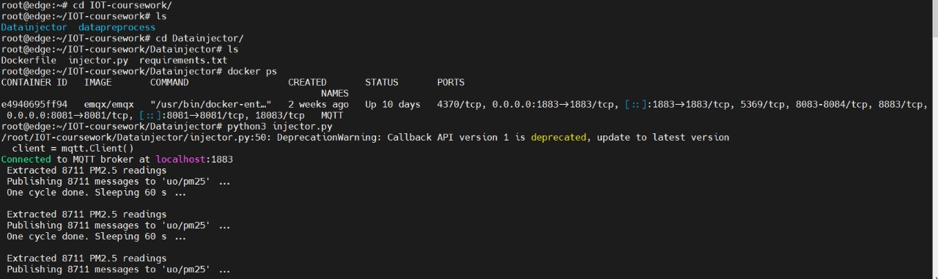
The above snippet shows the directory, files and the execution for task 1.
- The EMQX MQTT broker image was first pulled from Docker Hub using the docker pull command.
- Developed the data injector script to fetch the data from the Urban Observatory using the provided link.
- The script processes the data that is fetched and only takes the PM2.5 reading that too only timestamp and value
- After extracting the necessary fields, the data injector publishes the PM2.5 reading to the EMQX MQTT broker.
- The data is published under the MQTT topic uo/pm25. When we run the script it connects to the MQTT broker.
- Multiple PM2.5 readings are sent until we do not stop the loop by ourself.

Task 2: Designing a Data Preprocessor Operator
Objective: The primary objective of this task is to build a data injector that retrieves real-world data from the Urban Observatory and forwards it to an MQTT broker, enabling its use in the subsequent task.

Implementation:
- The preprocess.py script subscribes to the MQTT topic uo/pm25 using the Paho MQTT client.
- It collects the incoming data from the topic uo/pm25.
- The script filters the data and filter out outliers>50.
- Then it calculate the average value from the PM2.5 data
- Then the Script sends the calculated average value to RabbitMQ for further processes.
Results:
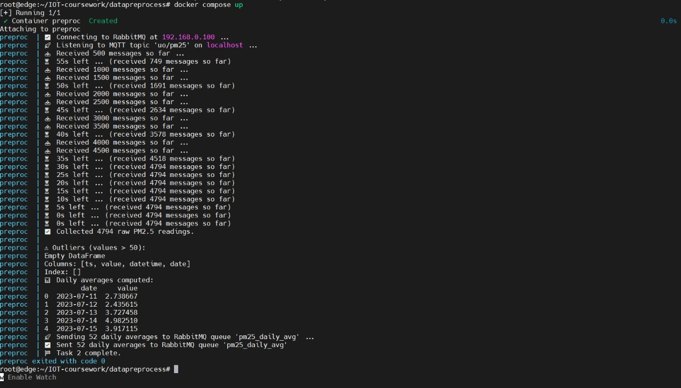
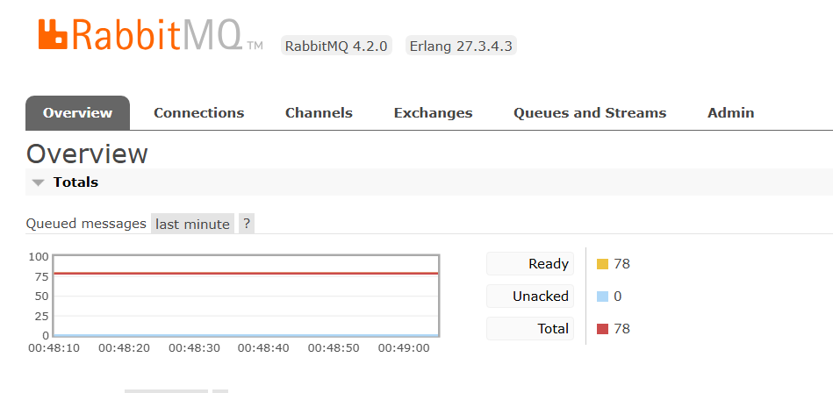
The above image shows that the processed data is successfully send to the RabbitMQ which will then be used by the task 3.

Task 3: Cloud Data Visualization and Forecasting.
Objective:
- Create a data visualization and forecasting operator
- Read the processed PM2.5 data from the RabbitMQ queue
- Visualize the daily average PM2.5 trends using Matplotlib
- Apply the Prophet model to forecast PM2.5 levels for the next 15 days
Implementation:
- The operator connects to RabbitMQ and then it continuously listens for the next message.
- The received data is stored in a list for easy data visualization.
- Daily Average PM2.5 are plotted using Matplotlib.
- Future forecast are generated through Prophet Model.
- Both the images are saved for the future reference.

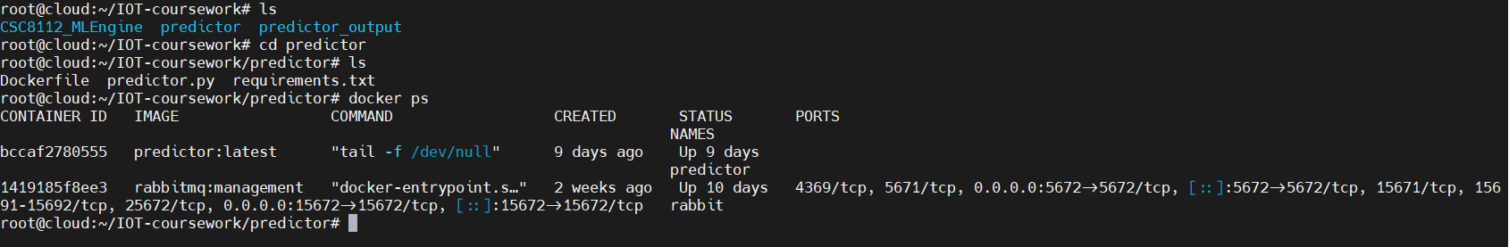

predictor container is running…….

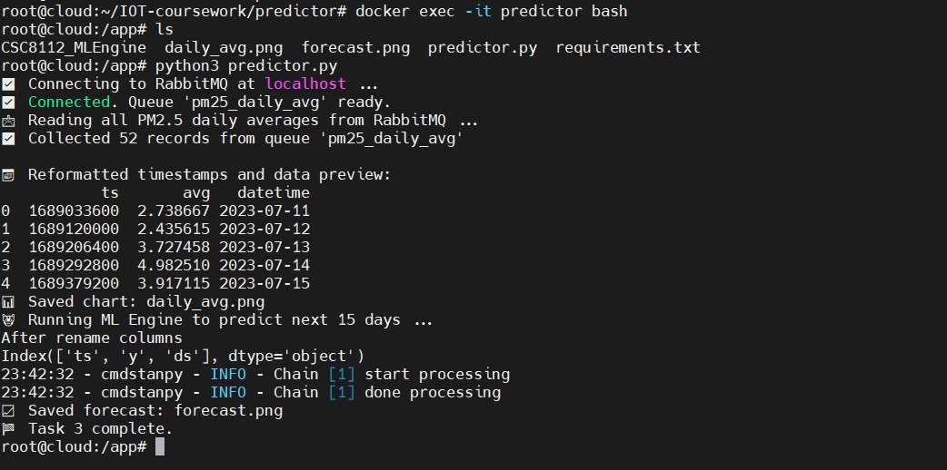

Results:
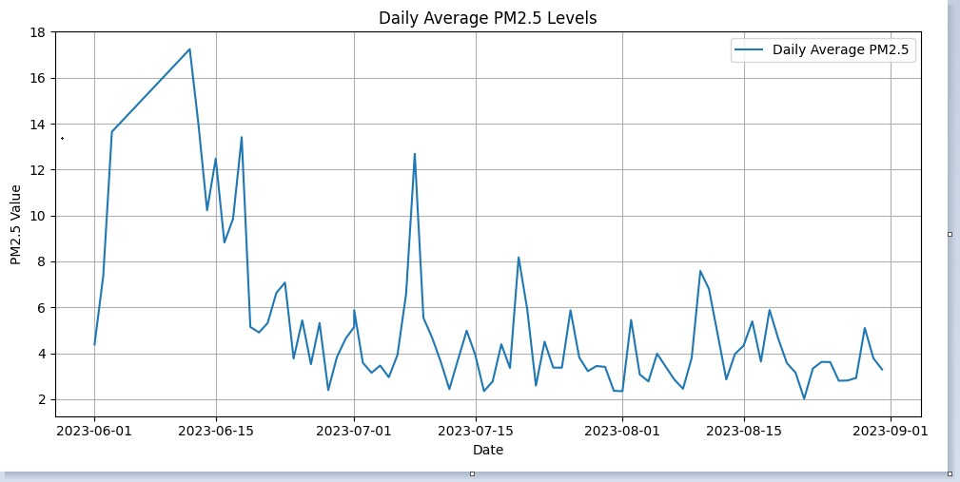The graph shows the reading of daily average PM2.5 reading received from the RabbitMQ.
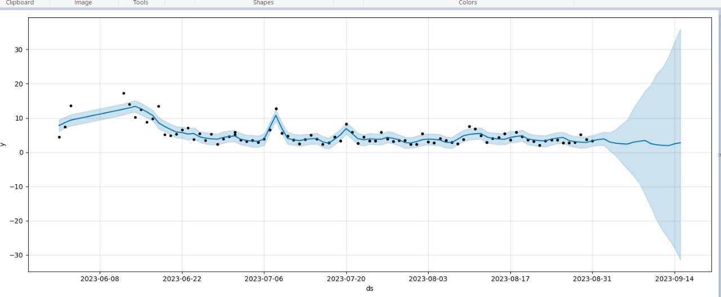
Plot for forecast of 15 days prediction.
The graph show the forecast of PM2.5 generated by the Prediction Model. Which will help in future for predicting the air quality.
Task 4: Local Model Training and Edge Inference for Air Quality Classification
Objective:
- Train a machine learning model to classify air quality levels.
- The classification categories are: Green: Good ;Yellow: Moderate; Red: Poor.
- Convert the trained model into TensorFlow Lite format for edge deployment.
- Then tests and evaluates the model accuracy.

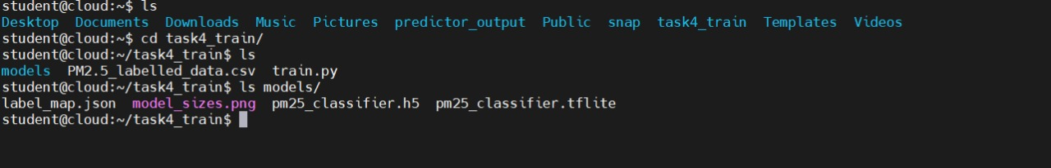
The above image shows the directory and the files that are there in it. Inside the model there are the tflite model, model_sizes,
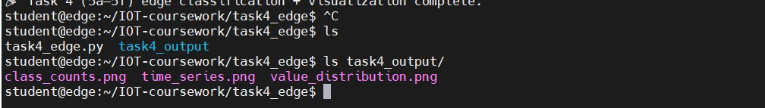

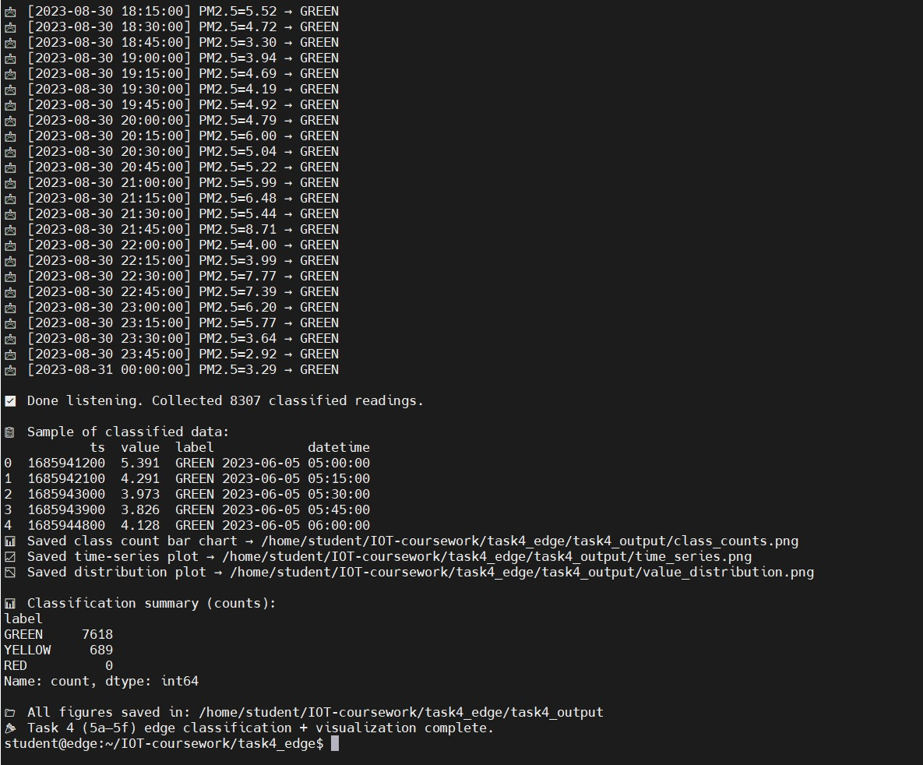
This snippet shows the classified reading is collected and all the plots are required are generated. And also the data is classified as Red, Green, Yellow depending upon there values.
Plots:
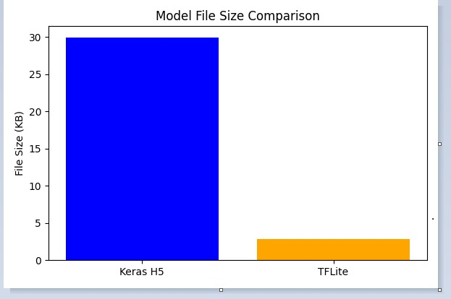
The TFLite model is significantly smaller than the original Keras H5 model, making it more efficient for edge deployment. This reduction in file size helps improve loading speed and reduces memory usage on resource-constrained devices.
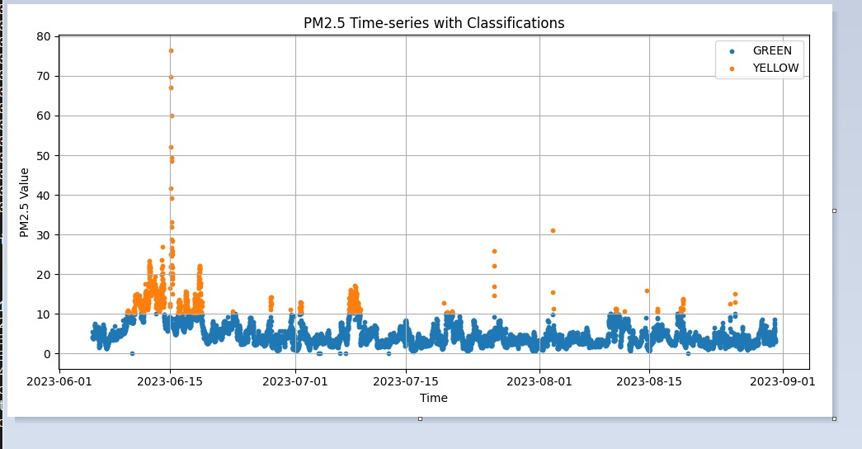
The time-series plot shows how PM2.5 values fluctuate over time, with most readings falling in the “Green” (Good) air quality category. Occasional spikes are classified as “Yellow” (Moderate), indicating short periods of reduced air quality within the dataset.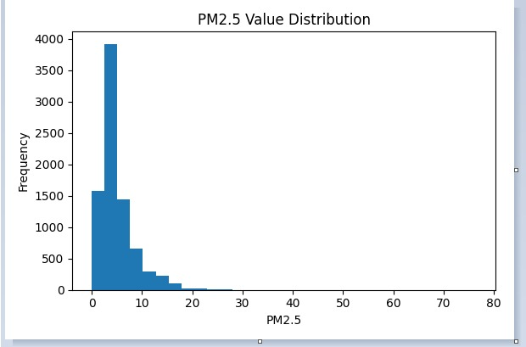
The histogram shows that most PM2.5 readings fall within the lower range, indicating generally good air quality across the dataset. Only a small number of readings reach higher PM2.5 levels, highlighting occasional spikes but rare severe pollution events.
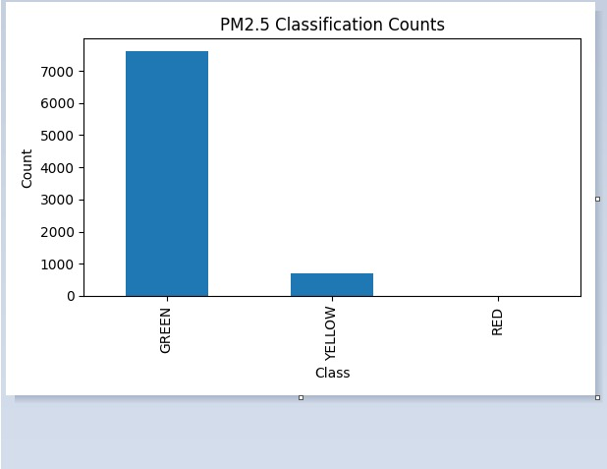
The classification count shows that the majority of PM2.5 readings fall under the “Green” category, indicating good air quality most of the time.

